1. Scan Data Sheet, put in U:\Projects\Colorado_River\Kemp_Breeze_SWA\Data\Sediment\PIT_Tagged_Rocks\Data\Field_Forms
2. Digitize Data sheet in correct sheet within "U:\Projects\Colorado_River\Kemp_Breeze_SWA\Data\Sediment\PIT_Tagged_Rocks\Data\KB_PIT_Tagged_Rocks_2024.xlsx". For example, if the scanned data sheet was printed from Deploy_2024, then fill in the sheet in the Deploy_2024 tab.
   1. If needed, follow instructions for correcting M34 Detections data
3. Manually copy and paste each new data sheet into the “allAfterFieldData” tab, including comments like “M34 Detection only” or anything included on field sheet

# Process for Correcting M34-only detections Data

Requirements

* Eric has made a pivot table in U:\Projects\Colorado_River\Kemp_Breeze_SWA\Data\Sediment\PIT_Tagged_Rocks\Data\Detections\KB_PITRocks_AllDetections_xxxxxx.xlsx of M34 Tags needed to be added to digitized data sheet
* M34 and Relocate Survey data has been added to U:\Projects\Colorado_River\Kemp_Breeze_SWA\GIS\Kemp_Breeze_SWA.gdb

Process

1. Navigate to "U:\Projects\Colorado_River\Kemp_Breeze_SWA\Data\Sediment\PIT_Tagged_Rocks\Data\Detections\KB_PITRocks_AllDetections_xxxxxx.xlsx" and find pivot table/list of tags with just M34 detections that Eric has presumably made
2. Open "U:\Projects\Colorado_River\Kemp_Breeze_SWA\Maps\PIT_Rocks\KempBreezeSWA_PITRocks_xxxx_Analysis.mxd. Work off this document
3. Copy tag number from KB_PITRocks_AllDetections_xxxxxx.xlsx. Find M34 detections layer in GIS and select for that point using Select BY attribute (TAGID = xxxxx)
4. Go to digitized data sheet in KB_PIT_Tagged_Rocks_XXXX and find tag number. Infer and enter RelocateID based off other relocateIDs around it (ie, if the next rock is 50435, the one before would be 50434). Comment that this is an M34 detected point.
5. We now want to add this point spatially to the corresponding relocate survey file. Open editing session in GIS with Relocate Survey layer.
   1. ie if this M34 detection was part of the Relocate 2024 survey, you would use the Relocate 2024 layer
6. In the desired Relocate File, Create new Feature by selecting “Editing windows -> Create Features” (pictured). Make sure the Relocate file is selected in the Create Feature toolbar (pictured), then click the desired point on the map from M34 layer that was selected previously.
   1. This spatially adds the point to the attribute table, but won’t add desired columns yet

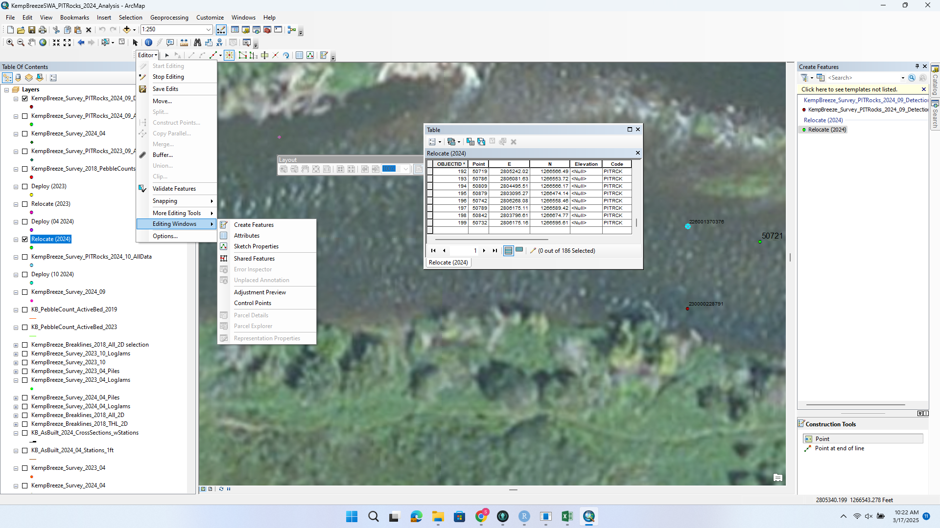

1. Select the new point in the attribute table and add desired text columns: importantly, add the point number that was inferred from the data sheets in the Point column
2. Calculate northing and easting by right clicking the desired column and selecting “calculate geometry”. For northing, use the Y coord and easting use the X. Default CRS should be fine since the data is already in a desired CRS
3. Save edits.
4. Note on original scanned data sheets of the new point number that was found with M34
5. Note RecapID on KB_PITRocks_AllDetections_xxxxxx list.
6. Repeat as needed until all M34 detections from KB_PITRocks_AllDetections_xxxxxx are found.